**1. Toy Car Project**

A project consists of a lcd as head to display image(emotion, info and etc), a body with module port to connect with different types of modules and a base(interior can be a hdd (SD Card) or lithium ion battery) with roller to move around like a tank.

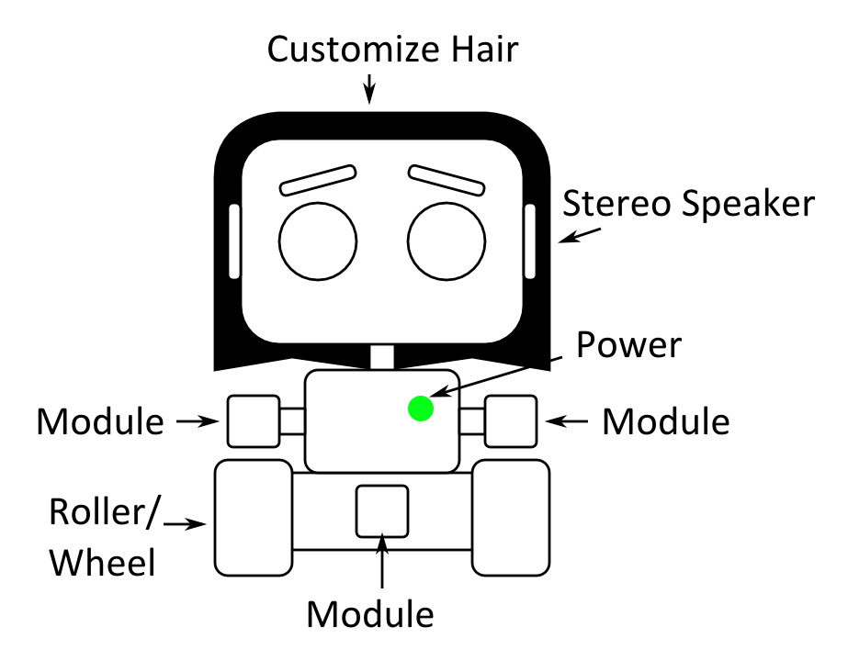

Prototype Design Sketch

**1.1 Modules**

* Air Conditioner Temperature control with AI Machine Learning
* Camera as CCTV or Webcam
* Alarm
* Robot Arm
* Fan Blade as Drone
* Patrol AI
* Drones control for area surveillance (WiFi/BLE)

**1.2 Hardware**

* Raspberry Pi 3 Model B

**1.3 Programming**

* Python (Raspbian)
* OpenCV
* Tensor Flow
* Node.js

**1.4 Systems**

* Vision:
  + Face Detection(Phase 1)
  + Face Recognition(Phase 1)
  + Facial Expression(Phase 2)
  + Object Detection(Phase 2)
  + Path Finding(Phase 2)
  + Fall Avoidance(Phase 1)
* Sound:
  + Voice Recognition(Phase 1)
  + Sound Direction Detector(Phase 2)
* Wireless Functionality:
  + Phone streaming and linking(Phase 1.5)
  + Smart House Assistant(Phase 1 with Voice Recognition done)
  + Google Assistant(Phase 1 with Voice Recognition done)
* AI:
  + Emotion Engine(Phase 2)
  + Behavior Engine(Phase 2)

**1.5 Milestone**

* Image Recognition
  + Items: Face Detection, Distance Calculation
  + PIC: Lim Lik Yeu
  + ETD: 30 June 2017
* Voice Recognition
  + PIC: Chin Yuen Ho
  + ETD: 30 June 2017
* Next Task to be determined once milestones above reach: Core Master